# Project resources

Assignment folder (EVERYTHING FROM DIAGRAMS AND SHIT IS IN HERE): <https://drive.google.com/drive/folders/1vtp11nIDyAt3pOJPsyViTT0S5PvUaEea?usp=sharing>

Main architecture diagram:

<https://drive.google.com/file/d/1h-Pg85y2T0ICi6fsfiQD5FyB2CMIJi_3/view?usp=sharing>

Photo upload UML collaboration diagram: <https://drive.google.com/file/d/1TIEMPfUxDgS41pIwtO02GX5DDwods4Ot/view?usp=drive_link>

Video upload UML collaboration diagram: <https://drive.google.com/file/d/1AAT4S2qRsfaAvomsWvtdG7WTUEqicb9s/view?usp=drive_link>

Get photos/videos UML collaboration diagram: <https://drive.google.com/file/d/1MNYTxhZj0cUa5RV2gjHPFKWK0MiZUMvZ/view?usp=drive_link>

# What the app will do

* Requires all users to be authenticated to use the application. Authentication will be done through Cognito Hosted UI.
* Lets authenticated users upload and view photos and videos. Users can only see the photos and videos they have uploaded.
* For each uploaded photo, generates two thumbnail versions (mobile and desktop) and identifies tags in it.
* For each uploaded video, transcodes it into a suitable format (what kind of format it is we don’t care at this point).

# Assumptions:

* Number of daily users: 300
* Number of daily photo uploads per user: 5
* Number of daily video uploads per user: 0.5
* Number of daily view requests per user: 5
* Maximum photo size: 10MB
* Maximum video size: 1GB

# AWS services used

1. Lambda: for backend logic.
2. API Gateway: lets clients interact with backend logic, acts as an interface between the frontend and backend.
3. S3: One bucket stores HTML, CSS, and JS files. Another bucket stores users’ uploaded photos and videos.
4. Elemental MediaConvert: For video transcoding.
5. DynamoDB: For storage of photo/video metadata. Photo metadata contains: uploader’s username, title, description, date added, keywords, s3_name, tags. Video metadata contains: uploader’s username, title, description, date added, keywords, s3_name.
6. CloudFront: Used for caching content.
7. Route 53: Used to access the application with a custom domain name.
8. Cognito: Used for customer authentication and authorization.
9. SNS: Decoupling
10. SQS: Decoupling
11. Rekognition: Identifies tags from photos.

# Alternative/additional services to consider

* Fargate (compare with Lambda)
* Elastic Transcoder (compare with Elemental MediaConvert)
* ~~Event Bridge~~
* ~~CloudWatch (for logging and monitoring purposes)~~
* ~~AWS Shield, AWS WAF (for CloudFront, API gateway protection from attacks?)~~

# **Alternatives:**

* [Huy] Compare SQL and NoSQL databases. Compare key-value data model vs other NoSQL models like document, graph, etc. (We choose DynamoDB, which is key-value)
* [Minh] Compare Lambda vs AWS Fargate (for container orchestration, also serverless). (We choose Lambda, but explain why not Fargate)
* [Dũng] Compare two-tier architecture vs three-tier architecture. (We choose three-tier, but explain why not two-tier).
* [Tung] Compare Amazon Cognito vs Amazon Identity & Access Management (IAM). (We choose Cognito for user authentication, but explain if we can use IAM, and if yes what are the limitations.)
* [Trung] Compare Elemental CloudConvert vs Elastic Transcoder for video transcoding tasks. (We choose Elemental CloudConvert, but explain why it is the better alternative).

# Service descriptions:

* [Trung] Route 53 and CloudFront
* [Minh] Lambda and API Gateway
* [Huy] DynamoDB and S3
* [Dũng] Elemental MediaConvert
* [Tùng] Cognito, SNS, SQS, Rekognition

References:

Serverless architecture and event-driven architecture (có vẻ 2 cái này khác nhau?? Not sure):

* [Serverless Computing – Amazon Web Services](https://aws.amazon.com/serverless/) (trong này có liệt kê các services mình có thể dùng trong một serverless architectures. Nếu mng k rõ sẽ dùng những gì có thể đọc qua)
* [Event-Driven Architecture](https://aws.amazon.com/event-driven-architecture/)

Two-tier architecture vs Three-tier architecture

* <https://byjus.com/gate/difference-between-two-tier-and-three-tier-database-architecture/> (

Cognito:

* [User pool attributes - Amazon Cognito](https://docs.aws.amazon.com/cognito/latest/developerguide/user-pool-settings-attributes.html)
* [Control access to a REST API using Amazon Cognito user pools as authorizer - Amazon API Gateway](https://docs.aws.amazon.com/apigateway/latest/developerguide/apigateway-integrate-with-cognito.html)
* [Understand Amazon Cognito user pools and identity pools | AWS re:Post](https://repost.aws/knowledge-center/cognito-user-pools-identity-pools)
* [Common Amazon Cognito scenarios](https://docs.aws.amazon.com/cognito/latest/developerguide/cognito-scenarios.html#scenario-backend)
* [Amazon S3: Allows Amazon Cognito users to access objects in their bucket - AWS Identity and Access Management](https://docs.aws.amazon.com/IAM/latest/UserGuide/reference_policies_examples_s3_cognito-bucket.html)
* [Access the S3 folder specific to particular user authenticated using Cognito | AWS re:Post](https://repost.aws/questions/QUutSZgcSPQJiCL5p-ln_aVA/access-the-s3-folder-specific-to-particular-user-authenticated-using-cognito)
* [Secure API Gateway using Cognito Authorizer (NEW)](https://www.youtube.com/watch?v=9crTLAT_4uY)
* [Using the Amazon Cognito hosted UI for sign-up and sign-in](https://docs.aws.amazon.com/cognito/latest/developerguide/cognito-user-pools-app-integration.html)
* [Should I use the hosted UI or create a custom UI in Amazon Cognito? | AWS Security Blog](https://aws.amazon.com/blogs/security/use-the-hosted-ui-or-create-a-custom-ui-in-amazon-cognito/)
* [Fine-grained Access Control with Amazon Cognito Identity Pools](https://www.youtube.com/watch?v=tAUmz94O2Qo)
* [Accessing AWS services using an identity pool after sign-in - Amazon Cognito](https://docs.aws.amazon.com/cognito/latest/developerguide/amazon-cognito-integrating-user-pools-with-identity-pools.html)

Video transcoding (Elemental CloudConvert, sample architectures, etc.):

* [Video on Demand | AWS Solutions](https://aws.amazon.com/solutions/implementations/video-on-demand-on-aws/?did=sl_card&trk=sl_card)
* [Architecture of media workflows - Amazon CloudFront for Media](https://docs.aws.amazon.com/whitepapers/latest/amazon-cloudfront-media/architecture-of-media-workflows.html)
* [AWS Media Services](https://aws.amazon.com/media-services/)
* [Architecture overview - Video on Demand on AWS Foundation](https://docs.aws.amazon.com/solutions/latest/video-on-demand-on-aws-foundation/architecture-overview.html)
* [AWS Elemental MediaConvert Features](https://aws.amazon.com/mediaconvert/features/)

Photo thumbnail creation, photo tagging with Rekognition

* [Tutorial: Using an Amazon S3 trigger to create thumbnail images - AWS Lambda](https://docs.aws.amazon.com/lambda/latest/dg/with-s3-tutorial.html) (k có service nào để tạo thumbnail cả :):) nên mình sẽ dùng lambda như assignment 2)
* [GitHub - aws-samples/lambda-refarch-imagerecognition: The Image Recognition and Processing Backend reference architecture demonstrates how to use AWS Step Functions to orchestrate a serverless processing workflow using AWS Lambda, Amazon S3, Amazon DynamoDB and Amazon Rekognition.](https://github.com/aws-samples/lambda-refarch-imagerecognition) (cái này hay vl và có thể đáp ứng đoạn “For example, in the future it may be desirable to add the ability to automatically identify tags in photos using AI.” - req 8b)

Database:

* [AWS NoSQL: Choosing the Best Option for You](https://bluexp.netapp.com/blog/aws-cvo-blg-aws-nosql-choosing-the-best-option-for-you#H_H2) (so sánh các NoSQL data models và NoSQL database services)
* [What is NoSQL? | Nonrelational Databases, Flexible Schema Data Models | AWS](https://aws.amazon.com/nosql/) (giống trên nma official :))))))
* [Amazon DocumentDB](https://aws.amazon.com/documentdb/)

API gateway:

* [Amazon API Gateway](https://docs.aws.amazon.com/apigateway/latest/developerguide/welcome.html)
* [Controlling access to HTTP APIs with JWT authorizers - Amazon API Gateway](https://docs.aws.amazon.com/apigateway/latest/developerguide/http-api-jwt-authorizer.html)
* [Set up API Gateway with a custom CloudFront distribution | AWS re:Post](https://repost.aws/knowledge-center/api-gateway-cloudfront-distribution)
* [Patterns for building an API to upload files to Amazon S3 | AWS Compute Blog](https://aws.amazon.com/blogs/compute/patterns-for-building-an-api-to-upload-files-to-amazon-s3/)
* [Controlling and managing access to a REST API in API Gateway](https://docs.aws.amazon.com/apigateway/latest/developerguide/apigateway-control-access-to-api.html)

Lambda:

* [Authorization@Edge – How to Use Lambda@Edge and JSON Web Tokens to Enhance Web Application Security | Networking & Content Delivery](https://aws.amazon.com/blogs/networking-and-content-delivery/authorizationedge-how-to-use-lambdaedge-and-json-web-tokens-to-enhance-web-application-security/)
* [Edge Computing| CDN, Global Serverless Code, Distribution | AWS Lambda@Edge](https://aws.amazon.com/lambda/edge/)
* <https://docs.aws.amazon.com/AmazonECS/latest/userguide/what-is-fargate.html>
* [Fargate vs Lambda, when to use which? - Stack Overflow](https://stackoverflow.com/questions/52275235/fargate-vs-lambda-when-to-use-which)
* <https://www.cloudzero.com/blog/fargate-vs-lambda>
* [Use API Gateway Lambda authorizers](https://docs.aws.amazon.com/apigateway/latest/developerguide/apigateway-use-lambda-authorizer.html)
* [Resilience in AWS Lambda](https://docs.aws.amazon.com/lambda/latest/dg/security-resilience.html) (there's information on Lambda redundancy -> fault tolerance)
* [Authorization@Edge using cookies: Protect your Amazon CloudFront content from being downloaded by unauthenticated users](https://aws.amazon.com/blogs/networking-and-content-delivery/authorizationedge-using-cookies-protect-your-amazon-cloudfront-content-from-being-downloaded-by-unauthenticated-users/)

CloudFront and Route 53:

* [Use CloudFront for API Gateway & S3 | by Mohd Afzal | VectoScalar | Medium](https://medium.com/vectoscalar/use-cloudfront-for-api-gateway-s3-both-cc0e30e0962a)

S3 & Glacier:

* [Amazon S3 Glacier Storage Classes | AWS](https://aws.amazon.com/s3/storage-classes/glacier/)
* [Uploading to Amazon S3 directly from a web or mobile application | AWS Compute Blog](https://aws.amazon.com/blogs/compute/uploading-to-amazon-s3-directly-from-a-web-or-mobile-application/) (we upload photos and videos with this technique)
* [Empty an Amazon S3 bucket with a lifecycle configuration rule | AWS re:Post](https://repost.aws/knowledge-center/s3-empty-bucket-lifecycle-rule)

Three-tier architecture:

* [Three-tier architecture overview - AWS Serverless Multi-Tier Architectures with Amazon API Gateway and AWS Lambda](https://docs.aws.amazon.com/whitepapers/latest/serverless-multi-tier-architectures-api-gateway-lambda/three-tier-architecture-overview.html)

Decoupling:

* [Get Started with Amazon S3 Event Driven Design Patterns | AWS Architecture Blog](https://aws.amazon.com/blogs/architecture/get-started-with-amazon-s3-event-driven-design-patterns/)

# Costs

Number of daily users: 300

Number of daily photo uploads per user: 5

Number of daily video uploads per user: 0.5

Number of daily view requests per user: 5

Maximum photo size: 10MB

Maximum video size: 1GB

Average video length: 5min

Notes: 1 month = 30.41 days

Region: Asia Pacific (Sydney)

| Service | Specifications | Cost (monthly) |
| --- | --- | --- |
| Route 53 | Tiered price for: 1  1 x 0.5000000000 USD = 0.50 USD  Total tier cost = 0.50 USD (Hosted Zone cost)  0 records x 0.0015 USD per record = 0.00 USD (RRset records cost)  **Total Hosted Zones & RRset records cost: 0.50 USD**  1 policy record per month x 50.00 USD = 50.00 USD (Traffic Flow cost)  1.966 million queries x 1000000 multiplier for million = 1,966,000.00 Standard queries in million  Tiered price for: 1966000.00 Standard queries  1966000 Standard queries x 0.0000004000 USD = 0.79 USD  Total tier cost = 0.79 USD (Standard queries cost)  Tiered price for: 1000 IP (CIDR) blocks  1000 IP (CIDR) blocks x 0.0000000000 USD = 0.00 USD  Total tier cost = 0.00 USD (IP (CIDR) blocks cost)  0.50 USD + 50.00 USD + 0.79 USD = 51.29 USD | **Total Monthly cost:** 51.29 USD |
| CloudFront | Price for countries outside of Australia, such as Canada, Asia Pacific, Europe,...  For example: USA  Tiered price for: 256 GB  256 GB x 0.0850000000 USD = 21.76 USD  Total tier cost = 21.76 USD (Data transfer out to internet from United States)  **Data transfer out to internet cost: 21.76 USD**  256 GB x 0.02 USD = 5.12 USD (Data transfer out to origin from United States)  **Data transfer out to origin cost: 5.12 USD**  2,500 requests x 0.000001 USD = 0.00 USD (HTTPS requests from United States)  **Requests cost: 0.00 USD**  21.76 USD + 5.12 USD = 26.88 USD (Total cost United States)  CloudFront price United States (monthly): 26.88 USD  Pice for users inside of Australia  Tiered price for: 256 GB  256 GB x 0.1140000000 USD = 29.18 USD  Total tier cost = 29.18 USD (Data transfer out to internet from Australia)  **Data transfer out to internet cost: 29.18 USD**  256 GB x 0.08 USD = 20.48 USD (Data transfer out to origin from Australia)  **Data transfer out to origin cost: 20.48 USD**  2,500 requests x 0.00000125 USD = 0.00 USD (HTTPS requests from Australia)  **Requests cost: 0.00 USD**  29.18 USD + 20.48 USD = 49.66 USD (Total cost Australia)  CloudFront price Australia (monthly): 49.66 USD | Monthly Cost: 436.99 USD |
| Lambda | Standard Lambda  Architecture x86  Number of requests = 141407 requests  Duration of each request = 500ms  Allocated memory: 128MB (min)  Ephemeral storage: 512 MB (min)  Lambda@Edge  Number of requests = 2,736,900 (30.41 days x 300 monthly users x 10 daily view requests x 20 photos/videos requested per view)  Duration = 500ms  Allocated memory = 128MB | Standard Lambdas = 0 USD  Lambda@Edge = 10.19 USD |
| API Gateway | REST API  141,407 monthly requests = (30.41 days x 300 monthly users x (5 daily photo uploads + 0.5 daily video uploads + 10 daily view requests)  No caching. | 0.49 USD |
| S3 | S3 standard  Standard storage = 2280.75 GB/month (300 daily users * 5 daily photo uploads * 30.41 days * 2 MB + 300 daily users * 0.5 daily video uploads * 30.41 days * 500MB)  Data will be moved into S3 through PUT, COPY, POST requests.  Average object size = 47.2MB ((2MB * 5 + 500MB * 0.5) / 5.5)  PUT, COPY, POST, LIST requests into S3 = 50177 (300 users * 5.5 requests per user * 30.41 days)  GET requests from S3 standard: 1824600 (300 users * 10 requests * 20 photos/videos retrieved per request * 30.41 days)  Data returned or scanned by S3: 0  Inbound Data Transfer from Internet (free)  Outbound data transfer to CloudFront (free) | 58.10 USD |
| DynamoDB | DynamoDB on-demand capacity ( standard table class)  Data storage size(100GB)  Number of write 50176.5 = 300 users per day * 30.41 days * 5.5 writes per days each user  Number of read: 91230 = 300 users per day * 30.41 days per month * 10 reads per day each user  Monthly read cost (Monthly): 0.04 USD = 136,845.00 total read request units x 0.0000002846 USD  DynamoDB data storage cost (Monthly): 28.50 USD  Monthly write cost (Monthly): 0.71 USD = 501,765.00 total write request units x 0.0000014231 USD  **Total Monthly cost: 29.25 USD** | 29,25 USD |
| SNS | Number of requests/notifications: 5 photos per user * 0,5 video per user * 300 users monthly * 30.41 days per month = 50,177 requests/notifications  50,177 requests - 1000000 free tier requests = -949,823.00 billable SNS requests per month  Max (-949823.000000 requests, 0 requests) = 0.00 requests  50,177 notifications x 0.00 USD = 0.00 USD (SQS Notifications cost)  **SNS Requests and** **Notifications cost (monthly): 0.00 USD** | 0.00 USD |
| SQS | Number of photo queue requests: 5 photos per user * 300 users monthly * 30 days monthly * 3 SQS requests per SNS requests = 135,000 requests  Number of video queue requests: 0.5 video per user * 300 users monthly * 30 days monthly = 4,500 requests  Number of queue requests: 135,000 + 4,500 = 139,500 requests  0.1395 requests per month x 1000000 multiplier for million = 139,500.00 total standard queue requests  Tiered price for: 139500.00 requests  139500 requests x 0.0000000000 USD = 0.00 USD  Total tier cost = 0.0000 USD (Standard queue requests cost)  **Total SQS cost (monthly): 0.00 USD** | 0.00 USD |
| Rekognition | Number of images processed with labels API calls per month: 45615  45615 = 300 users per day x 5 images per user per day x 30,41 days  **46515 x $0.0012 = $54.47** | $54.47 |
| Elemental MediaConvert | Output usage: 22807  22807 = 300 users per day x 0.5 video per day x 5 minutes per video x 30,41 days  **22807 x $0.0255 = $581.58** | $581.58 |
| Cognito | Number of Monthly Active Users(MAUs): 300 users monthly * 30.41 days monthly = 9,123 MAUs  9,123 MAUs x 0.75 SAML or OIDC federation requests = 6,842.25 SAML or OIDC federation MAU requests  6,842.25 SAML or OIDC federation MAUs - 50 free SAML or OIDC federation MAU requests per month = 6,792.25 billable SAML or OIDC federation MAU requests  Max (6792.25 billable SAML or OIDC federation MAU requests, 0 minimum billable SAML or OIDC federation MAU requests) = 6,792.25 total billable SAML or OIDC federation MAU requests  6,792.25 MAUs x 0.015 USD = 101.88 USD (SAML or OIDC federation MAU requests)  **SAML or OIDC federation cost (monthly): 101.88 USD**  9,123 MAUs - 50000 free MAU requests per month = -40,877.00 billable MAU requests  Max (-40877.000000 billable MAU requests, 0 Constant Unit) = 0.00 total billable MAU requests  Tiered price for: 0.00 MAUs  Total tier cost = 0.00 USD (User Pool MAUs)  **User Pool MAU cost (monthly): 0.00 USD**  **Advanced security feature cost (monthly): 0 USD**  **Cognito MAU cost (monthly): 101.88 USD** | $101.88 |
| Total: 1324.24/month | | |

The reason why all our services is very cost-effective is that:

Mediaconvert

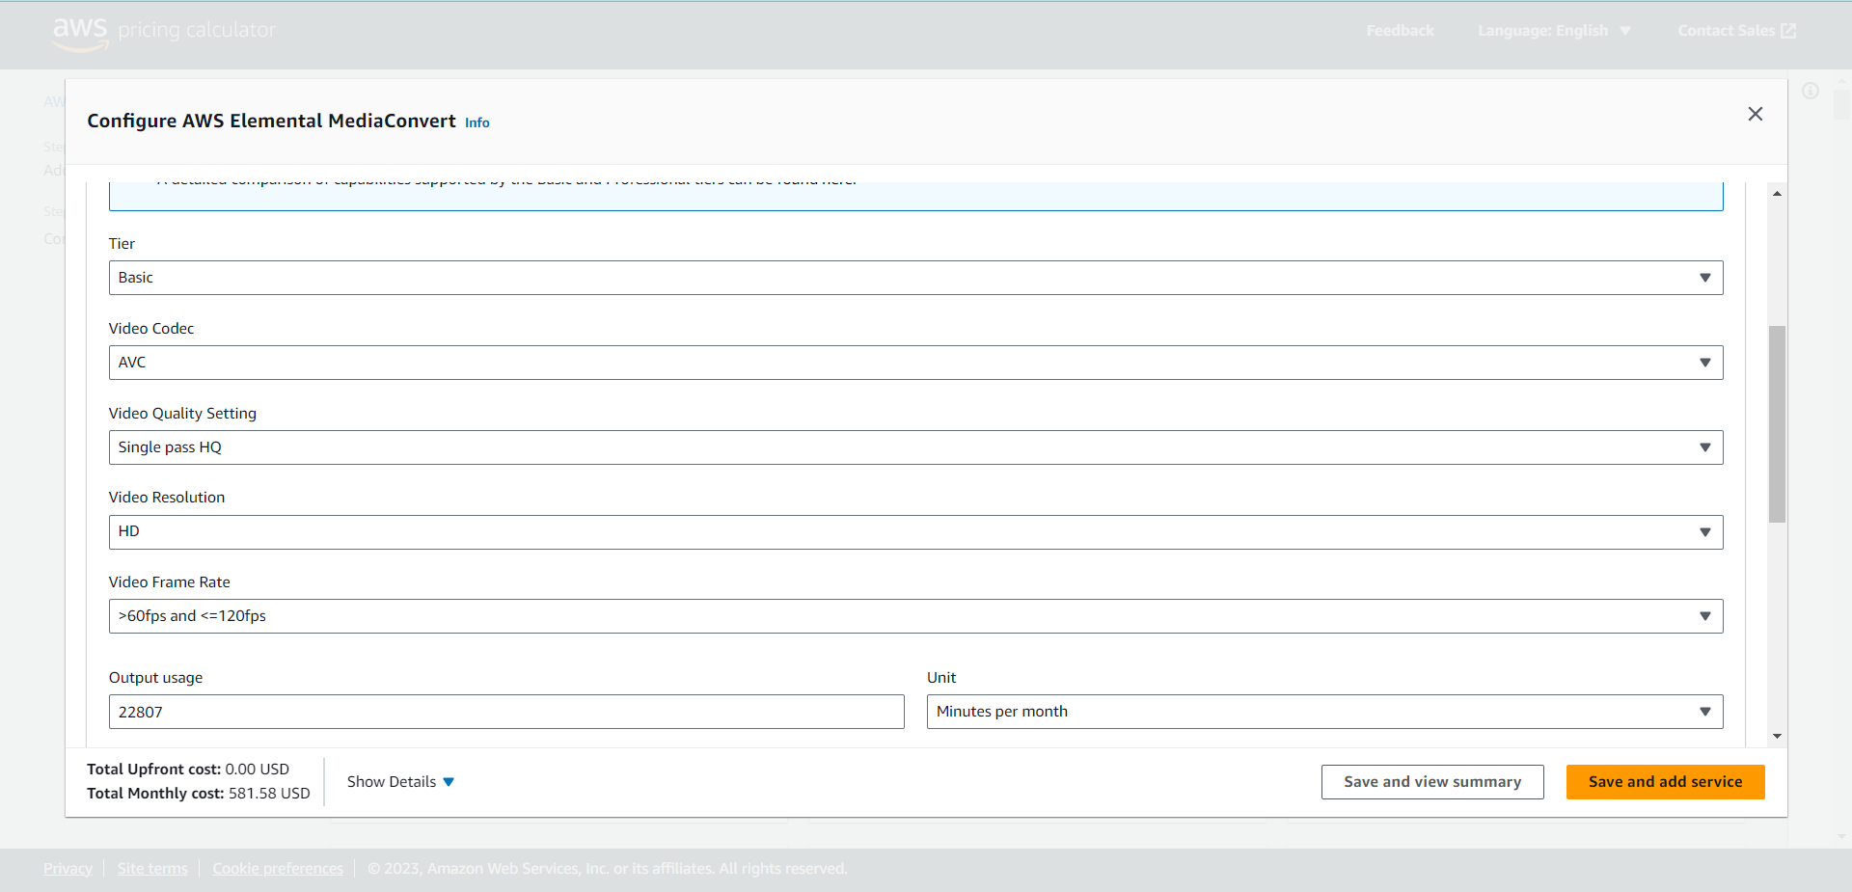

Rekognition

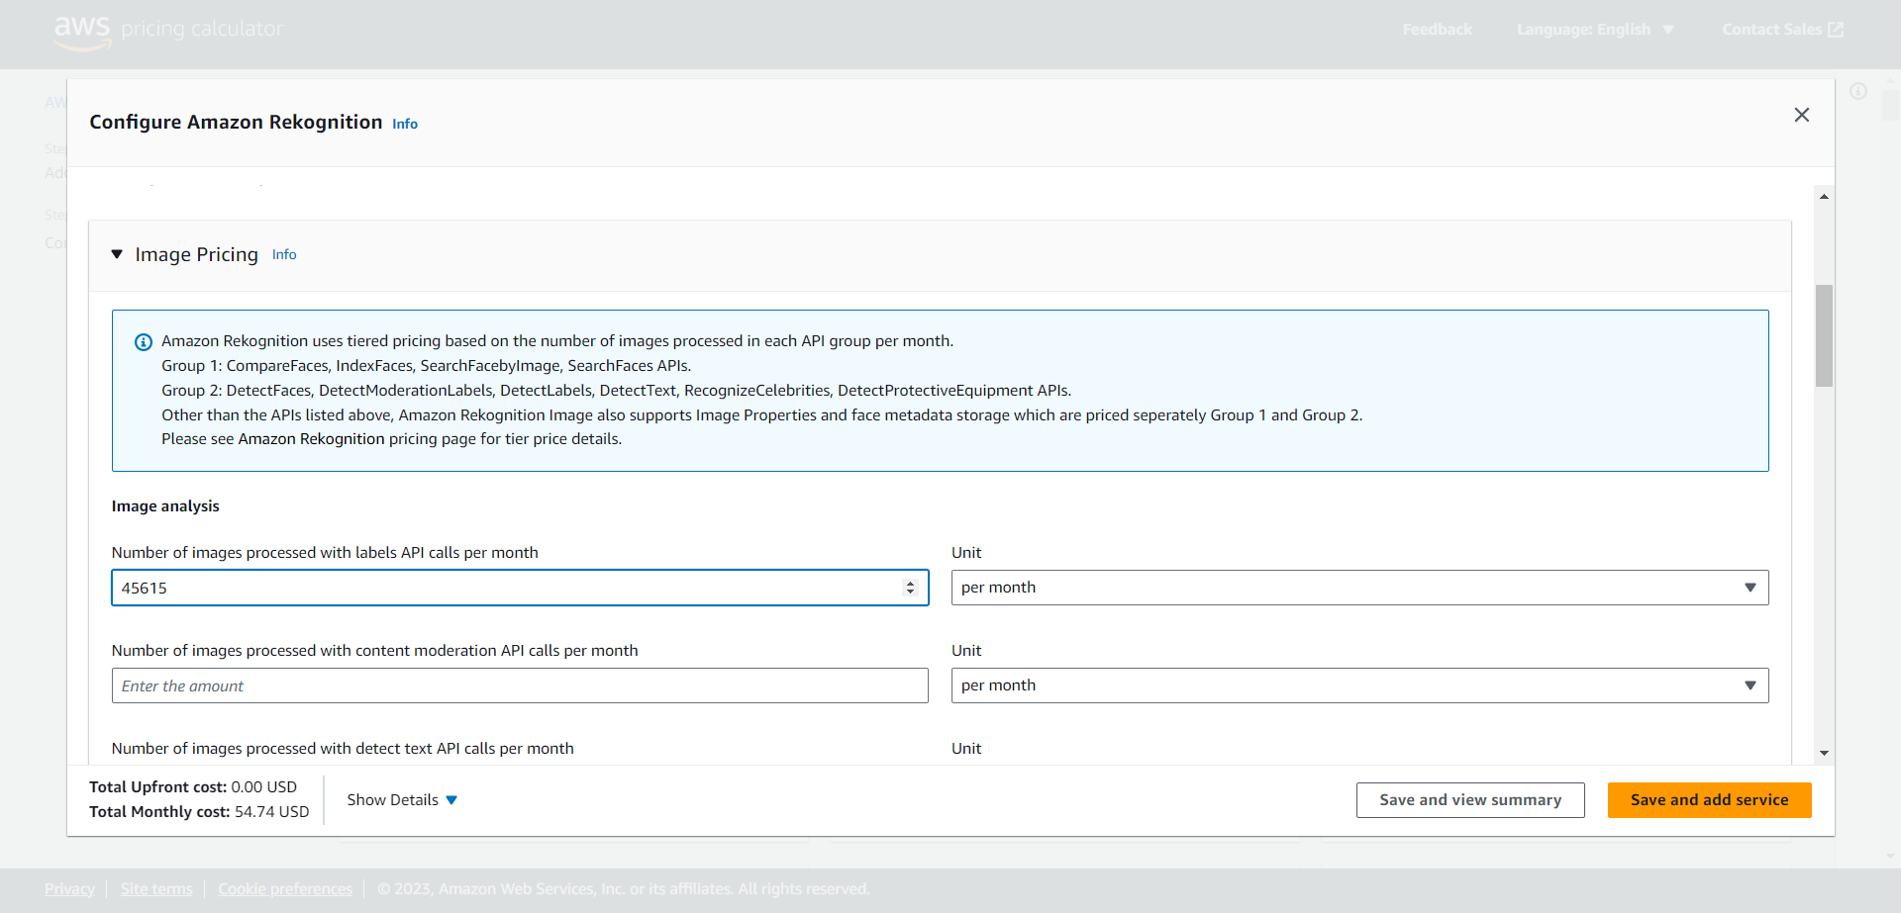

Route 53

<https://calculator.aws/#/estimate?id=ef20cad3a625cb7deb76f700f060cad88d380465>

REFERENCE LIST BẮT ĐẦU TỪ ĐÂY PLS

CÁI BÊN TRÊN ĐỂ HỒI TRƯỚC RESERACH THÔI

[1] <https://aws.amazon.com/dynamodb/features/>

[2] <https://aws.amazon.com/api-gateway/features/>

[3] <https://aws.amazon.com/api-gateway/pricing/>

[4] <https://aws.amazon.com/s3/security/>

[5] <https://aws.amazon.com/cognito/details/>

[6] <https://aws.amazon.com/cognito/pricing/>

[7] <https://docs.aws.amazon.com/lambda/latest/operatorguide/execution-environments.html>

[8] <https://docs.aws.amazon.com/amazondynamodb/latest/developerguide/AutoScaling.html>

[9] <https://aws.amazon.com/api-gateway/faqs/>

[10] <https://docs.aws.amazon.com/lambda/latest/dg/security-dataprotection.html>

[11] <https://aws.amazon.com/lambda/pricing/>

[12] <https://docs.aws.amazon.com/AmazonECS/latest/userguide/what-is-fargate.html>

[13] <https://aws.amazon.com/nosql/key-value/>

[14] <https://aws.amazon.com/dynamodb/>

[15] [https://aws.amazon.com/cloudfront/features](https://aws.amazon.com/cloudfront/features/?whats-new-cloudfront.sort-by=item.additionalFields.postDateTime&whats-new-cloudfront.sort-order=desc)/

[16] <https://aws.amazon.com/mediaconvert/faqs/>

[17] <https://aws.amazon.com/mediaconvert/pricing/>

[18] <https://aws.amazon.com/elastictranscoder/faqs/>

[19] <https://aws.amazon.com/blogs/architecture/get-started-with-amazon-s3-event-driven-design-patterns/>

[20] <https://docs.aws.amazon.com/AWSSimpleQueueService/latest/SQSDeveloperGuide/sqs-difference-from-amazon-mq-sns.html>

[21] <https://docs.aws.amazon.com/cognito/latest/developerguide/cognito-user-pools-app-integration.html>

[22] <https://docs.aws.amazon.com/apigateway/latest/developerguide/apigateway-integrate-with-cognito.html>

[23] <https://docs.aws.amazon.com/cognito/latest/developerguide/limits.html>

[24] <https://docs.aws.amazon.com/apigateway/latest/developerguide/apigateway-use-lambda-authorizer.html>

T lam 13-24 nhe

Anything else

REFERENCE LIST FORMATTED

[1] AWS Web Services. *Amazon DynamoDB features* [Online]*.* Available: <https://aws.amazon.com/dynamodb/features/>

[2] AWS Web Services. *Amazon API Gateway Features* [Online].Available: <https://aws.amazon.com/api-gateway/features/>

[3] AWS Web Services. *Amazon API Gateway pricing* [Online]. Available: <https://aws.amazon.com/api-gateway/pricing/>

[4] AWS Web Services. *Amazon S3 Security and Access Management* [Online]. Available: <https://aws.amazon.com/s3/security/>

[5] AWS Web Services. *Amazon Cognito Features*[Online]. Available: <https://aws.amazon.com/cognito/details/>

[6] AWS Web Services. *Amazon Cognito Pricing* [Online]. Available: <https://aws.amazon.com/cognito/pricing/>

[7] AWS Web Services. *Lambda execution environments* [Online]. Available: <https://docs.aws.amazon.com/lambda/latest/operatorguide/execution-environments.html>

[8] AWS Web Services. *Managing throughput capacity automatically with DynamoDB auto scaling* [Online]. Available: <https://docs.aws.amazon.com/amazondynamodb/latest/developerguide/AutoScaling.html>

[9] AWS Web Services. *Amazon API Gateway FAQs* [Online]. Available: <https://aws.amazon.com/api-gateway/faqs/>

[10] AWS Web Services. *Data protection in AWS Lambda* [Online]. Available: <https://docs.aws.amazon.com/lambda/latest/dg/security-dataprotection.html>

[11] AWS Web Services. *AWS Lambda Pricing* [Online]. Available: <https://aws.amazon.com/lambda/pricing/>

[12] AWS Web Services. *What is AWS Fargate?* [Online]. Available: <https://docs.aws.amazon.com/AmazonECS/latest/userguide/what-is-fargate.html>

[13] AWS Web Services. *What Is a Key-Value Database?*[Online]. Available: <https://aws.amazon.com/nosql/key-value/>

[14] AWS Web Services. *Amazon DynamoDB*[Online]. Available: <https://aws.amazon.com/dynamodb/>

[15] AWS Web Services. *Amazon CloudFront Key Features* [Online]. Available: <https://aws.amazon.com/cloudfront/features/>

[16] AWS Web Services. *AWS Elemental MediaConvert FAQs* [Online]. Available: <https://aws.amazon.com/mediaconvert/faqs/>

[17] AWS Web Services. *AWSElemental MediaConvert Pricing* [Online]. Available: <https://aws.amazon.com/mediaconvert/pricing/>

[18] AWS Web Services. *Amazon Elastic Transcoder FAQs* [Online]. Available: <https://aws.amazon.com/elastictranscoder/faqs/>

[19] AWS Architecture Blog. *Get Started with Amazon S3 Event Driven Design Patterns* [Online]. Available: <https://aws.amazon.com/blogs/architecture/get-started-with-amazon-s3-event-driven-design-patterns/>

[20] AWS Web Services. *Differences between Amazon SQS, Amazon MQ, and Amazon SNS* [Online]. Available: <https://docs.aws.amazon.com/AWSSimpleQueueService/latest/SQSDeveloperGuide/sqs-difference-from-amazon-mq-sns.html>

[21] AWS Web Services. *Setting up and using the Amazon Cognito hosted UI and federation endpoints* [Online]. Available: <https://docs.aws.amazon.com/cognito/latest/developerguide/cognito-user-pools-app-integration.html>

[22] AWS Web Services. *Control access to a REST API using Amazon Cognito user pools as authorizer* [Online]. Available: <https://docs.aws.amazon.com/apigateway/latest/developerguide/apigateway-integrate-with-cognito.html>

[23] AWS Web Services. *Quotas in Amazon Cognito* [Online]. Available: <https://docs.aws.amazon.com/cognito/latest/developerguide/limits.html>

[24] AWS Web Services. *Use API Gateway Lambda authorizers* [Online]. Available: <https://docs.aws.amazon.com/apigateway/latest/developerguide/apigateway-use-lambda-authorizer.html>